Hackathon Project Phases Template on Logo Craft: Innovative Logo Generation with Diffusion Technology project.

Hackathon Project Phases Template
Project Title: Logo Craft: Innovative Logo Generation with Diffusion Technology

Team Name: PROMPT ENGINEERS

Team Members:
- P. Gowri Priya
- S. Sowmya
- D. Satya Hareesha
- B. Kusuma

Phase-1: Brainstorming & Ideation
Objective:
The objective of "Logo Craft: Innovative Logo Generation with Diffusion Technology" is to develop an AI-powered system for creating high-quality and unique logos. By leveraging diffusion models, the project aims to automate the logo design process while allowing users to customize outputs through text prompts, sketches, or style preferences.

Key Points:
- Problem Statement:

○ In today's competitive market, establishing a memorable brand identity through a captivating logo is crucial for businesses.
○ However, many companies face challenges in creating unique and compelling logos that accurately represent their brand values and vision.
○ Logo Craft addresses this issue by leveraging cutting-edge Diffusion technology to generate custom logos based on user-provided descriptions.
○ By offering a seamless interface and intuitive controls, Logo Craft empowers businesses of all sizes to effortlessly create professional-grade logos that resonate with their target audience.
○ This project aims to revolutionize the logo design process, enabling businesses to stand out in a crowded marketplace and make a lasting impression on their customers.
- Proposed Solution:

Diffusion Model for Logo Generation
- Fine-tune a pre-trained diffusion model on a diverse logo dataset.
- Train the model to generate logos based on text prompts, sketches, and style preferences.
User Input & Customization Module
- Develop an interactive UI for user input through text, sketches, and style selection. • Implement real-time latent space editing to allow users to refine generated logos.
Style & Branding Adaptation
- Use style transfer to align logos with specific branding aesthetics.
- Provide multiple design variations tailored to industries and user preferences.
High-Resolution Output & Post-Processing
- Apply super-resolution techniques to enhance image quality.
- Support export in SVG, PNG, and vector formats for various applications.
Optimization & Scalability
- Deploy on a cloud-based infrastructure for efficient processing and scalability.
- Use model compression to ensure fast performance while maintaining quality.

- Target Users:

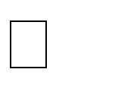
Startups & Small Businesses – Entrepreneurs and small business owners who need affordable, professional-quality logos without hiring a designer.
Marketing & Branding Agencies – Agencies looking for AI-assisted logo design tools to speed up the creative process and generate multiple variations for clients.
Freelance Graphic Designers – Designers who can use the AI-powered system as an inspiration tool or to generate quick logo drafts before refining them.
E-commerce & Online Sellers – Individuals or businesses selling products online (e.g., Etsy, Shopify, Amazon) who need quick, stylish branding solutions.
○ .
- Expected Outcome:
Meet Mark, a budding entrepreneur with a vision to launch his own business. As he embarks on his journey, Mark understands the importance of a striking logo that encapsulates the essence of his brand. However, Mark lacks the design skills and resources to create a professional logo. Enter Logo Craft. With Logo Craft, Mark can simply describe his brand's identity and values, such as "a modern tech startup with a focus on sustainability and innovation." Logo Craft then generates a range of logo concepts tailored to Mark's description. Inspired by the options, Mark selects the perfect logo that resonates with his vision, establishing a strong brand identity from the start.

Phase-2: Requirement Analysis
Objective:
The objective of "Logo Craft: Innovative Logo Generation with Diffusion Technology" is to develop an AI-powered system for creating high-quality and unique logos.

Key Points:
- Technical Requirements:

○ Programming Language: Python
○ Backend: Google Gemini Flash API
○ Frontend: Stream lit Web Framework
○ Database: Not required initially (API-based queries)
○
- Functional Requirements:

- Provide real-time customization options such as colour, typography, and layout adjustments.
- Offer multiple logo variations based on different styles, industries, and branding needs.
- Enable high-resolution logo downloads in formats like PNG, JPG, SVG, and vector files. • Allow users to save, edit, and retrieve past logo designs from their profile history.
- Implement AI-powered style transfer to match branding aesthetics and industry standards.
- Support interactive real-time previews for users to see logo transformations instantly..

3. Constraints & Challenges:

- High computational power requirement – Diffusion models require powerful GPUs for real-time logo generation, increasing infrastructure costs.
- Latency in logo generation – Ensuring fast response times while maintaining high-quality outputs is challenging due to model complexity.
- Ensuring uniqueness – Preventing similar or repetitive logo designs requires advanced fine-tuning of AI models.
- Maintaining aesthetic quality – AI-generated logos must adhere to industry design standards while offering creative flexibility.

Phase-3: Project Design
Objective:
Develop the architecture and user flow of the application.

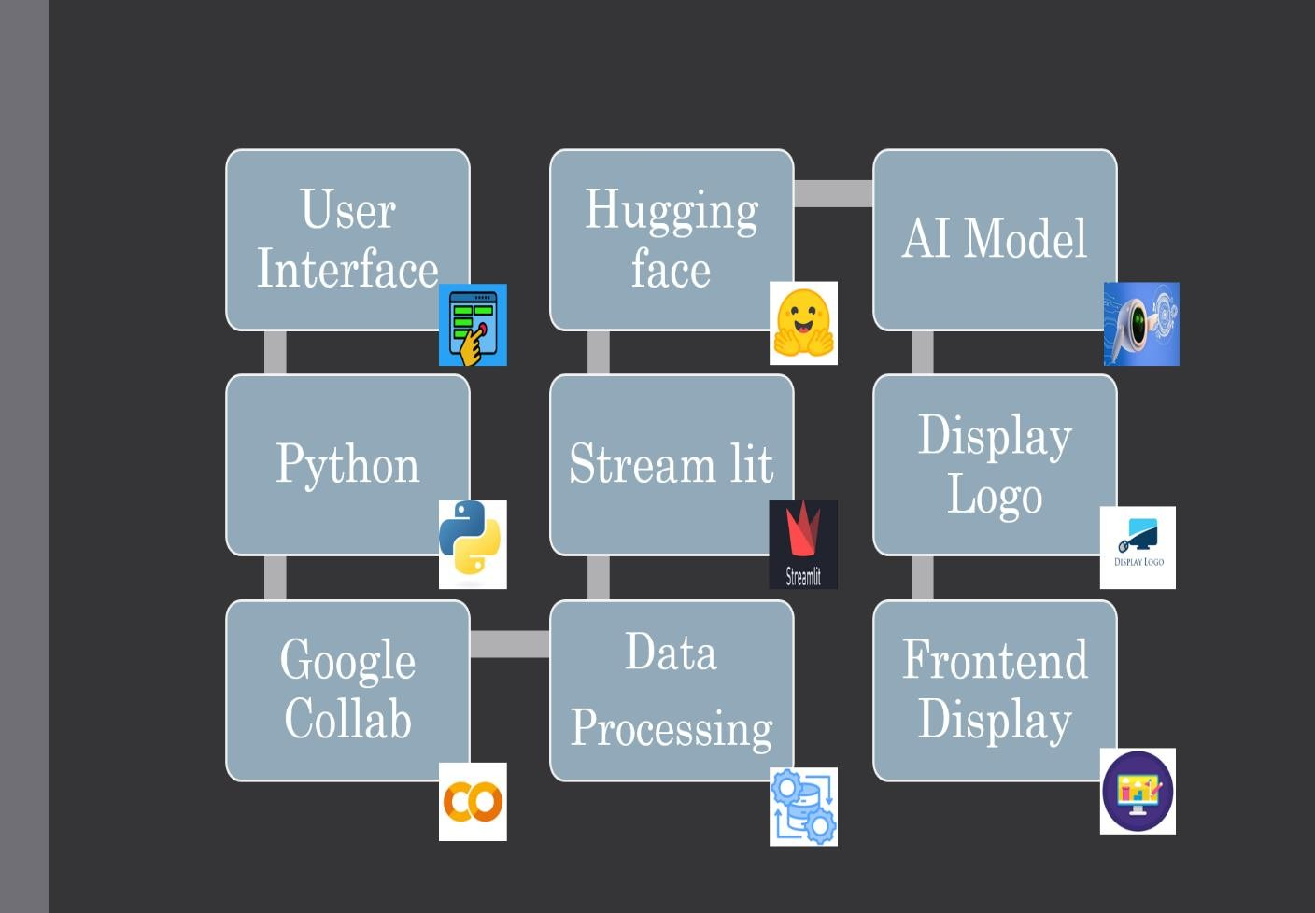

Key Points:
1. System Architecture:
- Frontend: Develop an interactive UI using Stream lit for real-time logo customization.
- Backend: Implement a Fast API or Flask-based backend to handle AI model requests.
- AI Model: Utilize Stable Diffusion fine-tuned for logo generation with branding constraints.
- Database: Store user preferences, generated logos, and brand guidelines using Firebase

1. User Flow:
Step 1: User logs in and enters logo preferences (industry, style, colours, keywords). Step 2: The backend calls the AI model (Stable Diffusion via Hugging Face API) to generate logo variations.
Step 3: The system processes the data and presents multiple logo design options. Step 4: User selects a design and customizes colours, fonts, and symbols with real time preview.
Step 5: User finalizes the logo and downloads it in multiple formats (PNG, SVG, PDF).
Step 6: The logo is saved to cloud storage, and AI suggests additional branding assets.

2. UI/UX Considerations:

○ Minimalist, user-friendly interface for seamless navigation.
○ Real-time logo customization with an intuitive design editor.
○ Dark & light mode for enhanced user experience.
○ Drag-and-drop functionality for easy logo adjustments.
○ AI-generated logo suggestions with interactive previews.

Phase-4: Project Planning (Agile Methodologies)
Objective:
Break down development tasks for efficient completion.

Sprint | Task | Priority | Duration | Deadline | Assigned To | Dependencies | Expected Outcome
Sprint 1 | Environment Setup  & API Integration | 🔴 High | 6 hours  (Day 1) | End of Day 1 | S. Sowmya | Google API Key,  Python, Stream lit setup | API connection established & working
Sprint 2 | Logo Search & Comparison | 🔴 High | 3 hours (Day 2) | Mid-Day 2 | D. Satya Hareesha | API response, UI elements ready | Search functionality with filters
Sprint 2 | Error Handling & Debugging | 🔴 High | 1.5 hours (Day 2) | Mid-Day 2 | P. Gowri Priya | API logs, UI inputs | Improved API stability
Sprint 3 | Testing & UI  Enhancements | 🔴  Medium | 1.5 hours  (Day 2) | Mid-Day 2 | B. Kusuma | API response, UI layout completed | Responsive UI, better user experience
Sprint 3 | Final Presentation & Deployment | 🔴 Low | 1 hour  (Day 2) | End of Day 2 | Entire Team | Working prototype | Demo-ready project

Sprint Planning with Priorities

Sprint 1 – Setup & Integration (Day 1)
(🔴 High Priority) Set up the environment & install dependencies.
(🔴 High Priority) Integrate Google Gemini API.
(🔴 Medium Priority) Build a basic UI with input fields.

Sprint 2 – Core Features & Debugging (Day 2)
(🔴 High Priority) Implement search & comparison functionalities. (🔴 High Priority) Debug API issues & handle errors in queries.

Sprint 3 – Testing, Enhancements & Submission (Day 2)
(🔴 Medium Priority) Test API responses, refine UI, & fix UI bugs.
(🔴 Low Priority) Final demo preparation & deployment.

Phase-5: Project Development
Objective:
The objective of "Logo Craft: Innovative Logo Generation with Diffusion Technology" is to develop an AI-powered system for creating high-quality and unique logos.

Key Points:
- Technology Stack Used:

○ Frontend: Google collab
○ Backend: Stream lit, Hugging Face
○ Programming Language: Python
- Development Process:
  - Implement API key authentication and Hugging Face API integration.
  - Develop AI-powered logo generation logic using diffusion models.
  - Optimize model inference for faster processing and high-quality outputs.
  - Design an intuitive UI for seamless user experience with Stream lit.
  - Enable customization options (colours, fonts, styles, and symbols).

1. Challenges & Fixes:

- Improve model accuracy and output quality by fine-tuning with high-resolution logo datasets.
- Optimize AI inference time using GPU acceleration and efficient model architecture.
- Implement real-time customization features for colours, fonts, and symbols.
- Integrate API key authentication and Hugging Face API for secure and scalable access.
- Enhance brand identity matching with AI-driven style recognition and recommendations.

Phase-6: Functional & Performance Testing
Objective:
Ensure that the Auto Sage App works as expected.

Test Case ID | Category | Test Scenario | Expected Outcome | Status | Tester
TC-001 | Functional Testing | Query "Best budget cars under ₹10 lakh" | Relevant budget cars should be displayed. | ✅ Passed | Tester 1
TC-002 | Functional Testing | Query "Motorcycle maintenance tips for  winter" | Seasonal tips should be provided. | ✅ Passed | Tester 2
TC-003 | Performance Testing | API response time under 500ms | API should return results quickly. | ✅ Passed | Tester 3
TC-004 | Bug Fixes & Improvements | Fixed incorrect API responses. | Data accuracy should be improved. | ✅ Fixed | Develop er
TC-005 | Final Validation | Ensure UI is responsive across devices. | UI should work on mobile & desktop. | ✅ Passed | Tester 2
TC-006 | Deployment Testing | Host the app using Stream lit Sharing | App should be accessible online. | 🔴 Deployed | DevOps

Final Submission
- Project Report Based on the templates
- GitHub/Code Repository Link
- Presentation

